

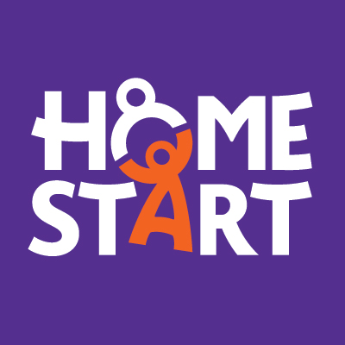

Shine Bright Project

A fund to support young people under 11 and parents in Tendring only.

Referral form

- Please note that all referrals must be made with the consent of the family. Have you discussed this referral with the family prior to completing this form? YES / NO

- The family must have at least one child under 11

Person referred…………………………………………………………………………………………… Address……………………………………………………………………………………………………………
………………………………………………………………Postcode …………………………………………
Tel. No …………………………Mobile No …………………..………
E mail ………………………………

Please provide some details about the adults caring for the child[ren]:

 | Name | Main carer √ | Resident in household√ | Comments
Mother/partner
Father/partner
Other main carer[s]
Other main carer[s]

This project has been designed to offer a mentoring and befriending solution focused service to local families across Colchester and South Tendring. The Home-Start Plus offer is to provide the assistance from another person to offer emotional and practical support.

Referred by: Date of referral:

Name of organisation/Individual

……………………………………………………………………………………………………………….

Email …………………………………………… Phone………………………………………………

Please add any background information that you think we would find useful here, the project leader may get in contact with you for further information.

Section 2 Family needs - Reason for referral and request being made
Home-Start Colchester and Home-Start Harwich are subcontracted to deliver this outcome focused service across North East Essex quadrant. This commissioned service is to support the following outcomes and support positive changes to take place. Our offer of support is via through home visiting or group activities.
Referrer to identify level of need as Level 1 Level 2 2 level 3
Needs | Tick if need | Identify here specific areas of need and how emotional and practical support along with advice and guidance can help.
Children in need of increased fun via funded opportunities in school holidays.

Parents to have respite in school holidays

Parents need help to improve their wellbeing:
- Support with benefits
- Support to build self esteem
- Support to build confidence and build ability to cope.
- Support to access health services/ community services

Family in need of financial assistance to buy key items during difficult times.

Children/ parents in need of emotional support.

Are there any Health and Safety issues that we need to consider when making home visits?
…………………………………………………………………………………………………………………………
…………………………………………………………………………………………………………………………

Details of children - Please note the family must have at least one child under the age of 11 years, (please include details of all children under 18)
Child’s name  Youngest first | Gender |  | Date of birth | Immigration status |  |  | Considered to be disabled by main carer? √ if yes | Asian or Asian British |  |  |  | Black or Black British |  |  | Chinese or Other Ethnic Group |  | Mixed | White |  |  | Subject to assessment of needs e.g. CAF/ UNOCINI (√) | Who is the lead professional? | Child in need √ | Child care/ protection plan (√)
Child’s name  Youngest first | Male | Female |  | Asylum seeker | Refugee | Pending | Considered to be disabled by main carer? √ if yes | Indian | Pakistani | Bangladeshi | Other Asian | Caribbean | African | Other | Chinese | Other Ethnic | Any mixed | British | Irish | Other White
C1.
C2.
C3.
C4.
C5.
C6.
C7.
C8
C9
C10.

Please complete those boxes which apply to any of the children
Note: the terms above are nation-specific - not all will be relevant in your area

Details of other members of the household with responsibilities for caring for the children
 | Gender |  | Date of birth | Immigration status |  |  | Consider themselves to be disabled | Asian or Asian British |  |  |  | Black or Black British |  |  | Chinese or Other Ethnic Group |  | Mixed | White
 | Male | Female |  | Asylum seeker | Refugee | Pending | YES? | Indian | Pakistani | Bangladeshi | Other Asian | Caribbean | African | Other | Chinese | Other Ethnic | Any mixed | British | Irish | Other White
Main Carer
Partner living in household

General Data Protection Regulation -If this referral is not signed, then personal data cannot be stored and the referral cannot be accepted.

Consent at the point of referral

A signature is required from the referrer to consent to the personal data on this form being processed by Home-Start.

Referrer…………………………………………………………………

Consent from the Family

Please tick and sign if you are happy to give consent

I I give consent for Home-Start to process the information on this form and store the information on a protected data base and family file.

I give consent to share my information and inform the health visitor or other agency, that they have requested Home-Start support and to share any information with them.

Parents signature……………………………………………………………………………….

Please now return this referral form: If emailing please send the document pass worded to
Office @homestartcolchester.org.uk.

If posting, please send marked confidential and post to:
Home-Start Colchester The Ark, Jack Andrews Drive, off Gavin Way Colchester Essex CO4 9FF. Tel 01206 854625

Thank you for taking time to provide this information which will help us to process the referral.
We are unable to process your referral until we have received this form. Please return this referral form : office@homestartcolchester.org.uk
Home-Start Colchester, The Ark, Highwoods Methodist Church, Jack Andrews Drive, Colchester, Essex C04 9FF. Tel: 01206 865349

