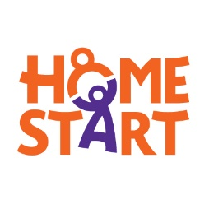


Group Registration form

Home-Start Colchester, Jaywick and Clacton registration for groups.

Please add your up-to-date details and give us permission to hold your

Parents Name…………

Address……
………………………………………………………………………… Postcode……………...
Email……………………………………… Mob…………………………….

Child’s name…

Date of Birth

What do you feel will be the benefit for you to attend this funded activity/

Are you interested in more information on the Household fund?

General Data Protection Regulation –To enable Home-Start Colchester to process the data on this form please tick and agree the following.

Please tick and sign if you are happy to give consent

I I give consent for Home-Start to process the information on this form and store the information on a protected data base for 12 months.

I agree that my information can be shared with funder and partners who may be able to help me further. Such as Wonde voucher so I can be issued a shop voucher or arrange a delivery.

I give permission for photographs to be taken of me (and my child) at group sessions and for them to be used to promote Home-Start Services for example on Facebook groups.

Parent signature………………………………………………………………………………. Or email to confirm consent.

Please return this form to Office@homestartcolchester.org.uk

